# Quarter Sprints - DONE

# Sounds Branch

## Graphical user interface Description automatically generatedSound for Player Movements

This feature was to add sounds to the player movements. The movement that I was working on was the walking sounds. I found a sound that suited the player and attached it to the code.

In the PlayerMovement.cs file I made a condition that checks if the player is ‘stepping’ to enable the sound.

## Sound for player Sword Attacks

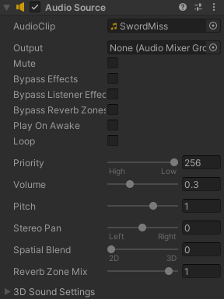In this feature I messed around with the sound effects needed to collaborate with the melee attack. I found two sounds that suit the situation and decided to use both.

In the Sword.cs file I modified it to play the sounds, one if a miss and two if a hit was made onto the enemy.

## Player Shield Sound

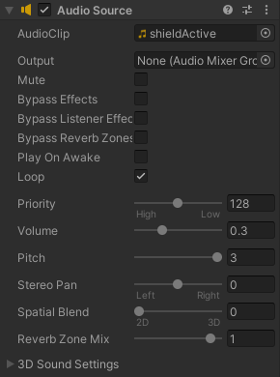This feature added sounds to the player shield action. The shield was activated using the Input.GetMouseButton(1) but there was conflicts using this function for this purpose.

So in the Shield.cs file I swapped that function into the GetMouseButtonDown(1) and set conditions to make it work. A Boolean condition was added because of complications that were not enabling the shield sound to function properly.

LINK TO COMMIT: <https://github.com/UTRGV-CS-Projects/202320-spring-2023-projects-prism-bossrush/commit/7cefedbbfb4af63c41eb128752bc5223f9e17ef9>

# Graphical user interface, text, application Description automatically generatedShield Animation Branch

## Shield Animations

In this feature I added a quick visual representation of the shield for the DEMO on Wednesday. This feature is not meant to be permanent but simply demonstrates the radius and shows it active and inactive. In the Shield.cs script I simply modified it to enable the component.

LINK TO COMMIT: <https://github.com/UTRGV-CS-Projects/202320-spring-2023-projects-prism-bossrush/commit/615df9a3e1ffee96ed7b64ab1de5c113256571c2>

# Arrow sound Branch

## Graphical user interface Description automatically generatedPlayer Bow Attack Sounds

This feature gives sound effects to the player shooting the arrow, there were minor complications in making this feature and we had to fix some conflicts in the merge. With Jonathan’s help we cleared the issues and I also added some variables for the colors within the attack.

## Player Attack bow Setup

This feature sets up the bow attack for the color system. In the RangeAttack.cs file I check and enable the file to collaborate with color stats from the game component.

LINK TO COMMIT: <https://github.com/UTRGV-CS-Projects/202320-spring-2023-projects-prism-bossrush/commit/3276166b36b58ff4ef9cf61943d1282466ef14a2>

# Shield Branch

## Player Block Shield

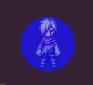This feature enables the player to block attacks from enemies. I modified the Shield.cs script to trigger the shield using the right click button. This enables the collider and makes the Health bar not decrease if hit. I also needed to modify the HealthBar.cs script to consider the shield in effect.

LINK TO COMMIT: [https://github.com/UTRGV-CS-Projects/202320-spring-2023-projects-prism-bossrush/commit/9665d1f3cfcee294662ab1a614f41f23b6523727](https://github.com/UTRGV-CS-Projects/202320-spring-2023-projects-prism-bossrush/commit/9665d1f3cfcee294662ab1a614f41f23b6523727#diff-6334354973e14f62589ae54c806c1947750febdf76afcab559a63681f1457f62)

# Sword Branch

## Player Attack Sword

This feature allows the player to attack with the melee weapon. A small range was added to simulate the attack area.

Within this area, the Sword.cs file check if an enemy is within that range and attacks it. A cool-down was given to the attack to prevent spamming. Also I wanted to make sure it was not stuck facing one direction and changed the PlayerMovement.cs file to move the sword attack with the direction it is facing. Also started a base for the color condition for the enemy.

LINK TO COMMIT: <https://github.com/UTRGV-CS-Projects/202320-spring-2023-projects-prism-bossrush/commit/851e10889e5a16180ad8bbb3938121dd352dcb63>

# Sword Swing Branch

## Sword Animations

This feature involved me making the animations for the sword attack. This feature is temporary as it will be fixed with better assets and stuff. Here I worked with an animator to also find the trigger to check if the player has or does not have color to set the animation and sword color for the player.

LINK TO COMMIT: <https://github.com/UTRGV-CS-Projects/202320-spring-2023-projects-prism-bossrush/commit/d00ee874f741f3a2076a8a59ef4e91c290b0ae95>

# MIDTERM POSTER/PRESENTATION

For the Midterm poster I added all the features that I have worked on and reformatted the poster to be more comprehensive and categorized what we worked on in groups. During the presentation we were a group of 3 so we took turns in switching one person every 20 minutes for the 1-hour duration and took notes of what people were saying, good and bad.

LINK TO POSTER: <https://docs.google.com/presentation/d/10wLmK0FxwSWo5cV9loCxp34gcb8ISPm5nu6fup7dYo8/edit?usp=sharing>